
Saad Mughal | F2023-009
Sheikh Muhammad Ibrahim | F2023-630
Khadijah Zahoor | F2023-956
Total Marks: 10
Due 4 January 2026

Operating Systems

RetroPie

Project Documentation

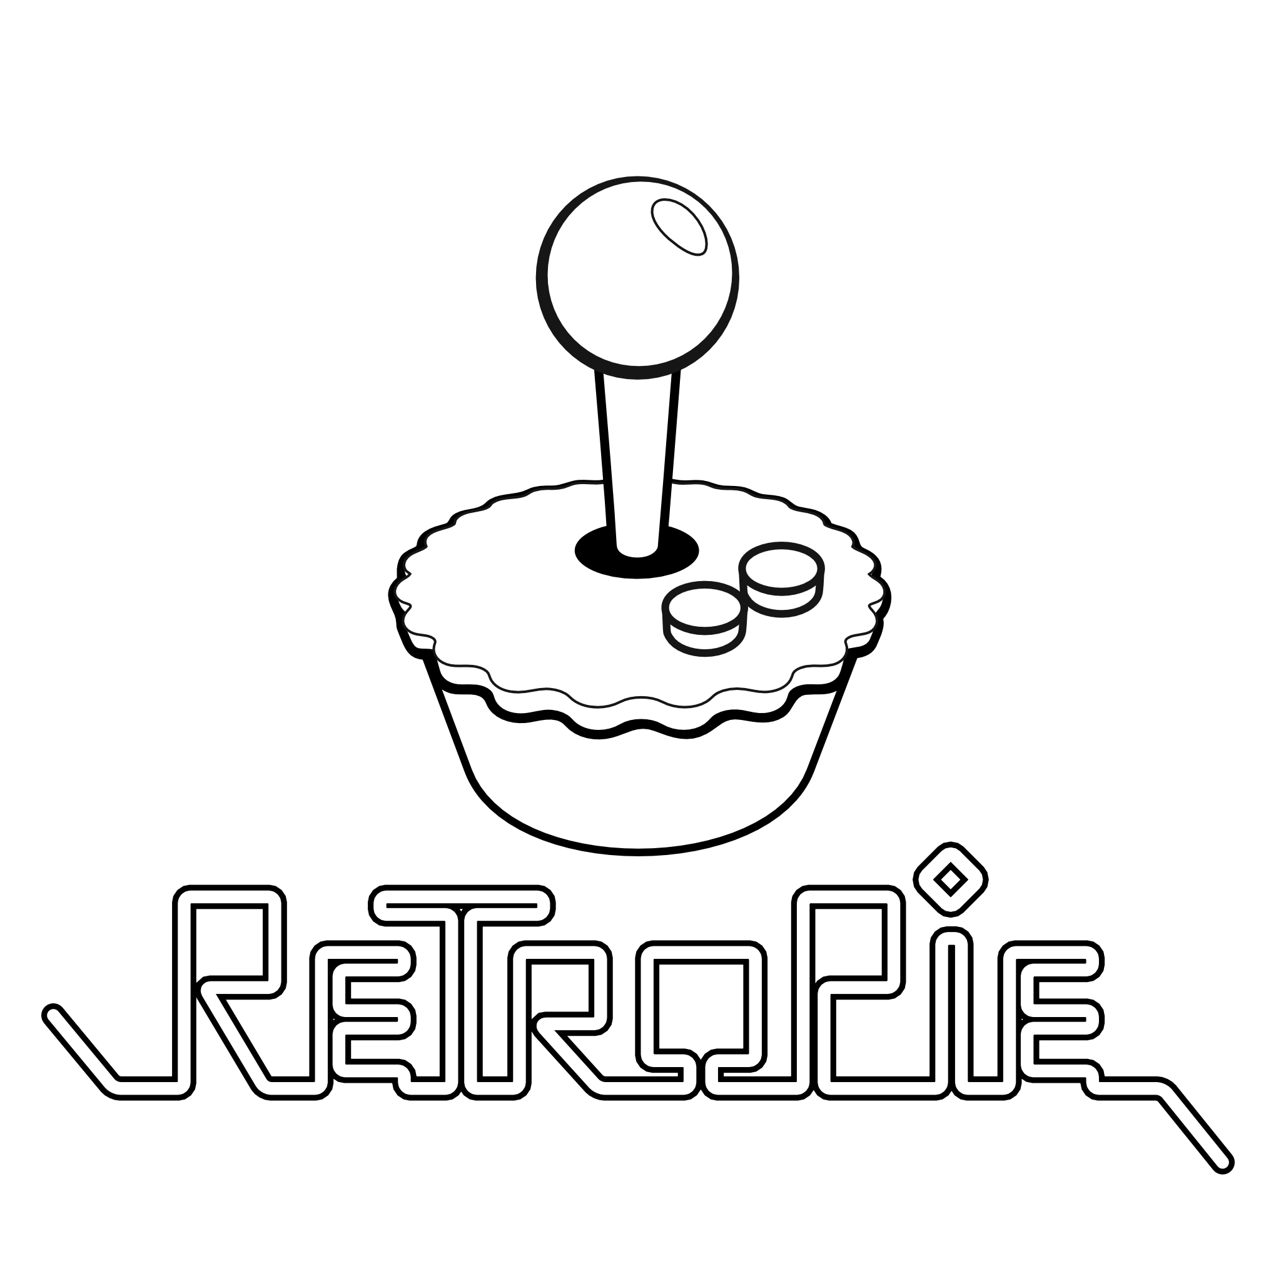

Course Lecturer: Noreen Khalid
Lab Instructor: Ali Hafeez Malik
Section: C

Table of Contents
1. Project Overview 3
1.1 Project Title 3
1.2 Team Members 3
1.3 Project Abstract 3
1.4 Project Objectives 3
2. Operating System Architecture 4
2.1 System Architecture 4
2.2 Key Operating System Concepts Demonstrated 4
Process Management 4
Memory Management 4
File System Management 5
Device Drivers & Hardware Abstraction 5
I/O Management 5
Boot Process 5
System Services & Daemons 6
3. System Requirements 6
3.1 Hardware Specifications 6
3.2 Software Components 7
4. Implementation Process 7
4.1 Installation Workflow 7
Step 1: Preparing the Operating System Image 7
Step 2: Flashing microSD Card 8
Step 3: Initial Boot and Configuration 11
Step 4: Controller Configuration 11
4.2 ROM Transfer and Organization 12
Network Transfer via SSH/SCP 12
File System Organization 13
4.3 System Configuration 14
Performance Optimization 14
5. Implementation Challenges 14
6. Testing and Performance Metrics 15
6.1 System Performance 15
6.2 Functional Testing 15
7. Learning Outcomes 16
7.1 Technical Knowledge Gained 16
7.2 Operating System Concepts Applied 16
8. Conclusion 17
8.1 Future Enhancements 17
9. References 17
10. Appendix 17

RetroPie Gaming Console on Raspberry Pi
Operating Systems Course Project Documentation

1. Project Overview

1.1 Project Title
RetroPie Gaming Console: A Custom Linux-Based Retro Gaming Operating System

1.2 Team Members
- Saad Mughal - F2023-009
- Sheikh Muhammad Ibrahim - F2023-630
- Khadijah Zahoor - F2023-956

1.3 Project Abstract
RetroPie is a Linux-based retro gaming operating system built on Raspberry Pi OS that transforms a Raspberry Pi into a dedicated gaming console. This project demonstrates core operating system concepts including process management, file system organization, device driver configuration, and system service administration. Implementation involves installing RetroPie on Raspberry Pi 4 hardware, configuring emulation software (RetroArch, EmulationStation), optimizing system performance, and managing ROM libraries. The project showcases practical applications of OS architecture, boot processes, I/O management, and hardware abstraction layers in a real-world embedded Linux environment.

1.4 Project Objectives
- Install and configure RetroPie OS on Raspberry Pi 4 hardware
- Demonstrate Linux-based operating system architecture and components
- Implement system-level configurations for gaming performance optimization
- Configure device drivers, I/O systems, and hardware abstraction
- Document hardware-software interaction and OS service management

2. Operating System Architecture

2.1 System Architecture
RetroPie runs on Raspberry Pi OS (Debian-based Linux) with the following layered architecture:

User Interface Layer
EmulationStation Frontend
Application Layer
RetroArch & Emulator Cores (Game Console Emulation)
System Services Layer
systemd, Samba, SSH, Network Services
Operating System Layer
Raspberry Pi OS (Debian Linux)
Kernel Layer
Linux Kernel (ARM Architecture)
Hardware Layer
Raspberry Pi Hardware (CPU, GPU, RAM, Storage, I/O)

2.2 Key Operating System Concepts Demonstrated

Process Management
- Emulators run as independent processes with dedicated resource allocation
- Multi-threading utilized for frame rendering and audio processing
- CPU scheduling optimized for real-time gaming performance (60 FPS target)
- Process priority management for system vs. emulation processes

Memory Management
- RAM allocation configured per emulator based on console requirements
- GPU memory split optimized (256MB GPU / 3.7GB system on 4GB Pi 4)
- Virtual memory management for large ROM loading

File System Management
- ext4 file system on microSD card for OS and data
- ROM organization: /home/pi/RetroPie/roms/[system]/
- Configuration files: /opt/retropie/configs/
- BIOS files: /home/pi/RetroPie/BIOS/

Device Drivers & Hardware Abstraction
- VideoCore VI GPU drivers for hardware-accelerated graphics
- USB/Bluetooth controller input device drivers
- ALSA audio subsystem for sound output
- HDMI display interface drivers

I/O Management
- Real-time controller input processing with minimal latency
- Video output buffering for 60Hz refresh rate synchronization
- Storage I/O optimization for ROM loading and save states

Boot Process
- Raspberry Pi firmware bootloader initialization
- Linux kernel loading and hardware detection
- systemd init system startup and service orchestration
- Auto-start configuration for EmulationStation on boot
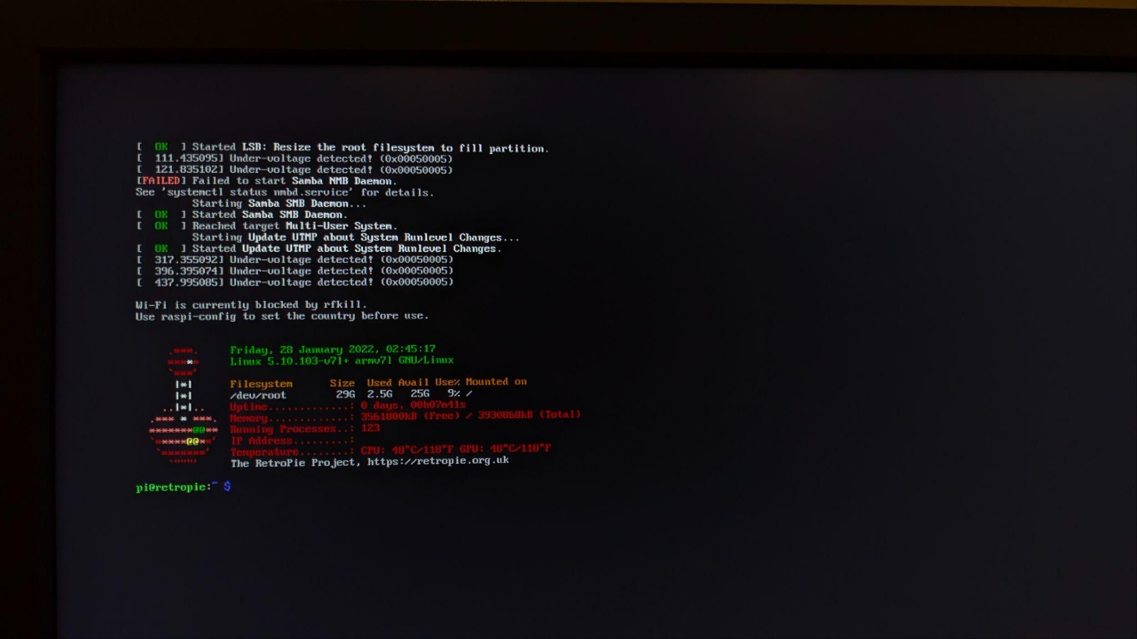
[Fig 2: Boot Sequence]

System Services & Daemons
- SSH daemon for remote terminal access
- Samba file sharing service for network ROM transfer
- Bluetooth service for wireless controller pairing

3. System Requirements

3.1 Hardware Specifications
Component | Specification
Main Board | Raspberry Pi 4 Model B, 4GB RAM
Storage | 32GB microSD Card (Class 10, UHS-I)
Power Supply | 5V/3A USB-C Power Adapter
Display | HDMI Monitor/TV (1080p)
Input Devices | USB Keyboard, USB Mouse, USB/Bluetooth Game Controller
Connectivity | WiFi 802.11ac/ Gigabit Ethernet
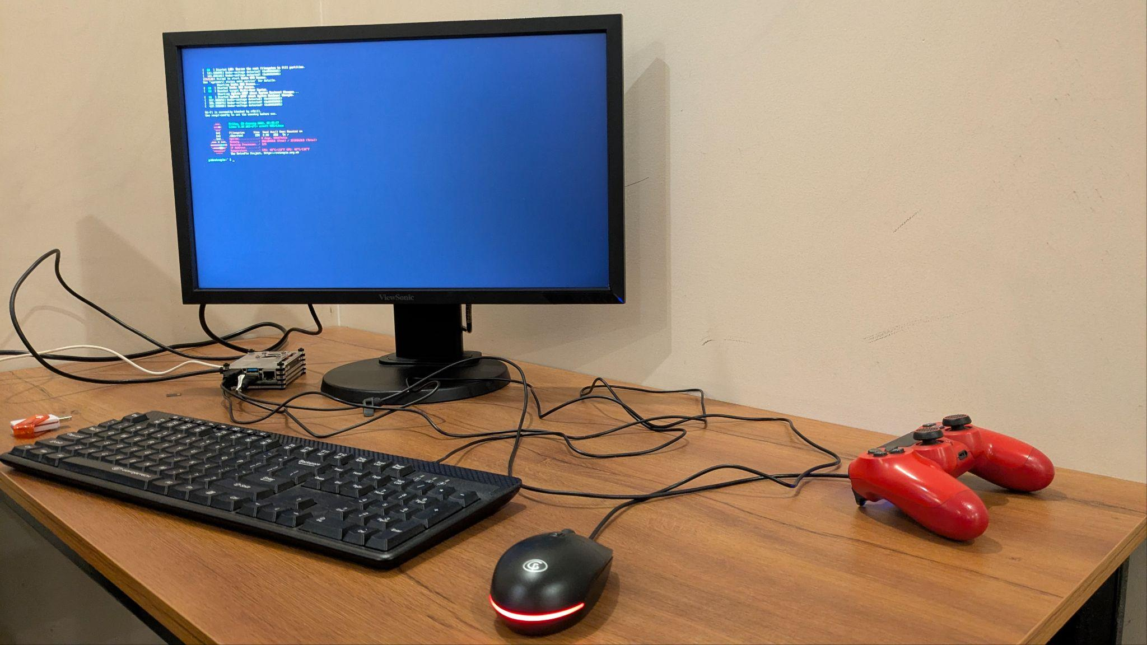
[Fig 3: Physical Setup]

3.2 Software Components
- RetroPie Version: 4.8 (released March 2022)
- Base OS: Raspberry Pi OS (Debian 11 Bullseye)
- Linux Kernel: 5.10.103-v7l+ (ARM architecture)
- Frontend: EmulationStation
- Emulation Framework: RetroArch with libretro cores

4. Implementation Process

4.1 Installation Workflow

Step 1: Preparing the Operating System Image
- Downloaded RetroPie 4.8 image from official repository (retropie.org.uk)
- Downloaded Raspberry Pi Imager tool for Windows
- Verified image integrity using MD5 checksum
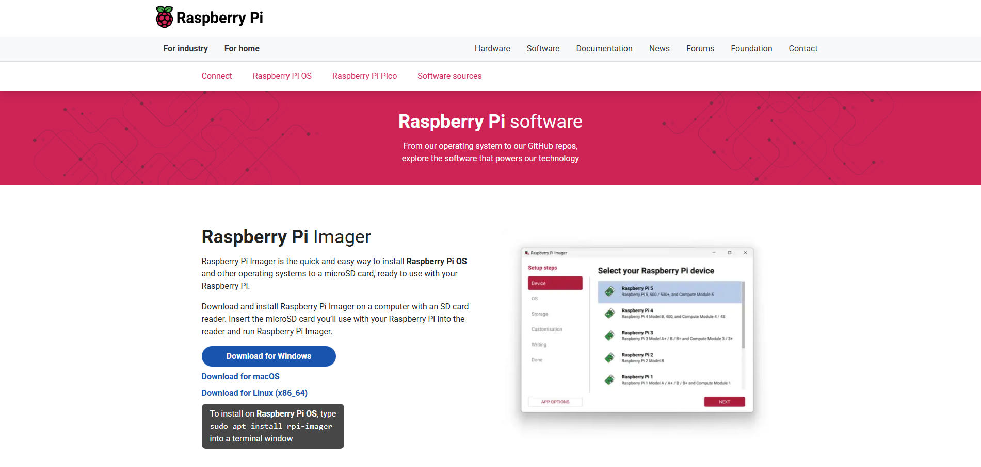
[Fig 4: Raspberry Pi Imager Download Page]
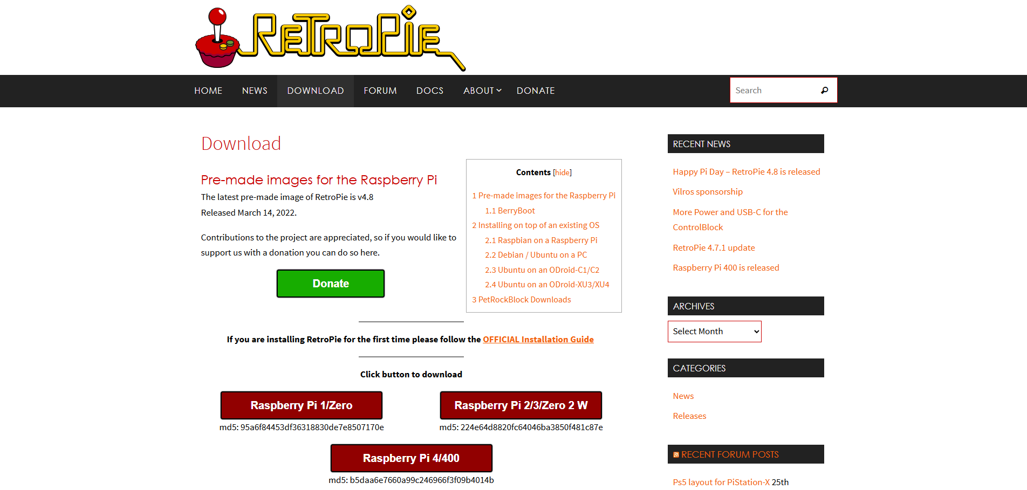
[Fig 5: RetroPie Download Page]

Step 2: Flashing microSD Card
- Launched Raspberry Pi Imager application
- Selected Raspberry Pi 4 as target device
- Selected 'Use custom' option and loaded RetroPie .img file
- Selected 32GB microSD card as storage device
- Initiated write process (completion time: ~8 minutes)
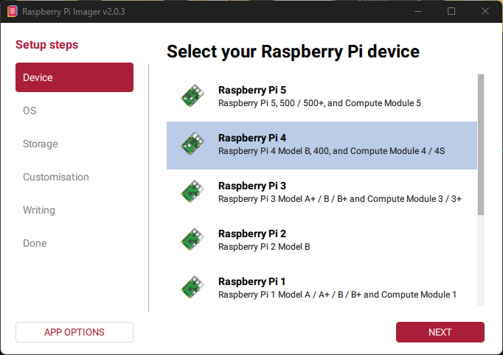
[Fig 6: Raspberry Pi Imager - Device Selection]
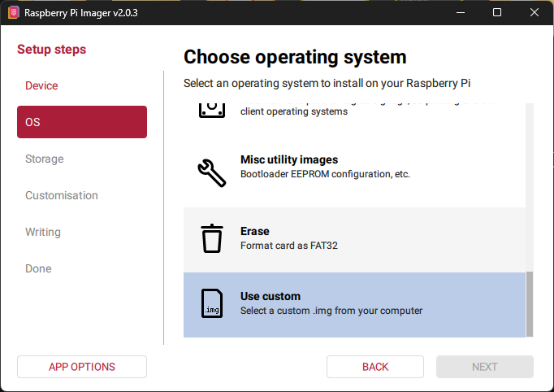
[Fig 7: Raspberry Pi Imager - OS Selection]
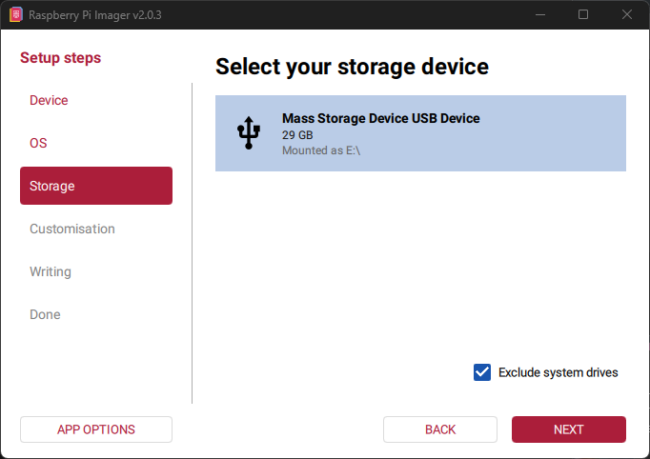
[Fig 8: Raspberry Pi Imager - Storage Selection]
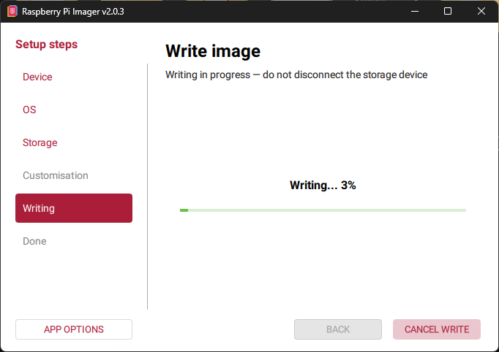
[Fig 9: Raspberry Pi Imager - Writing Progress]

Step 3: Initial Boot and Configuration
- Inserted microSD card into Raspberry Pi 4
- Connected HDMI display, keyboard, mouse, and power
- First boot initiated automatic file system expansion
- Configured WiFi network via raspi-config utility
- Enabled SSH service for remote administration
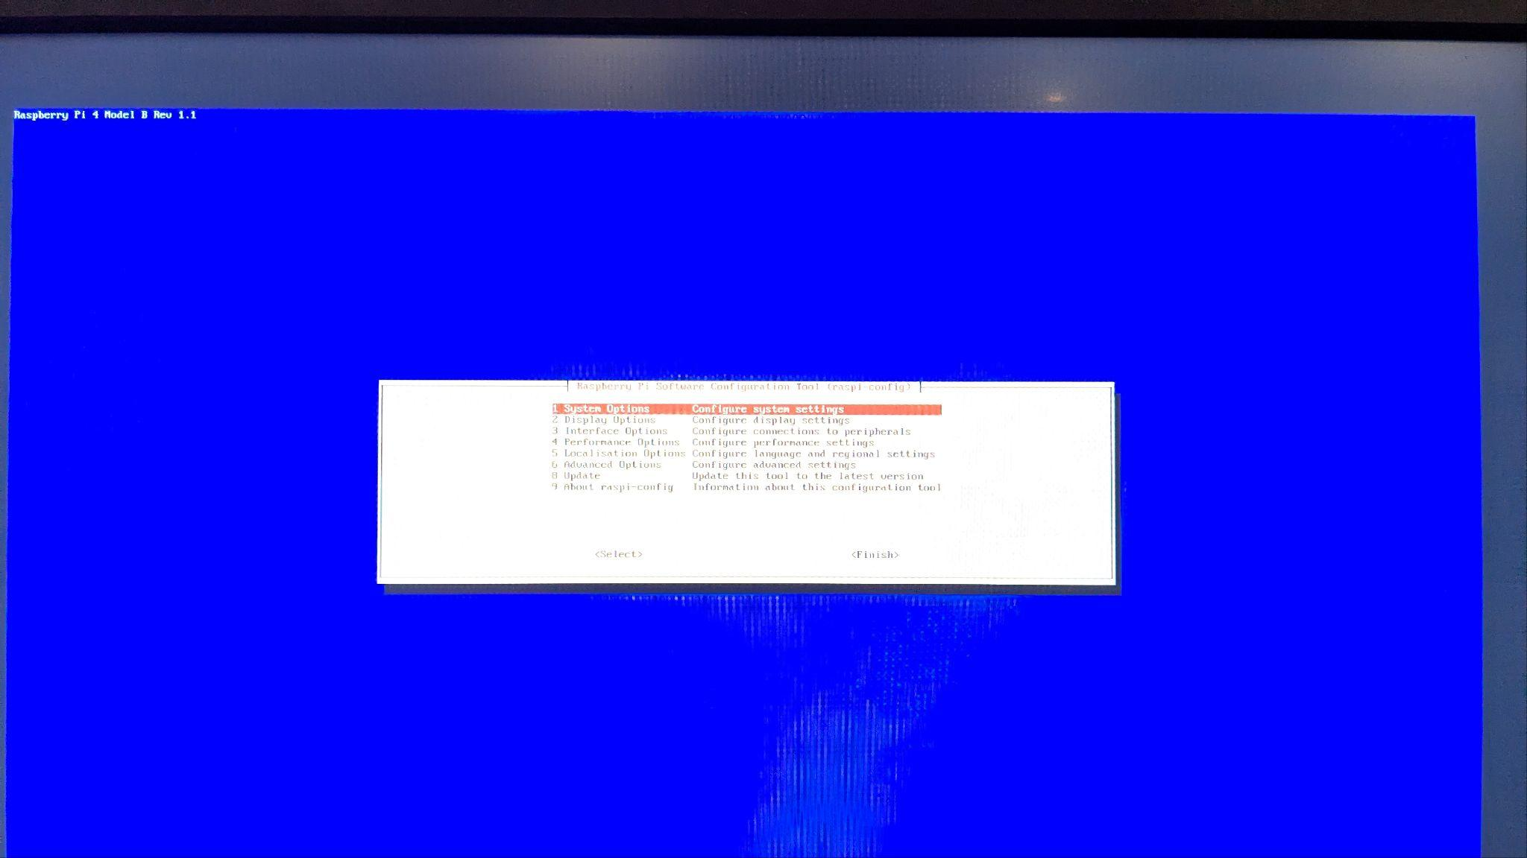
[Fig 10: raspi-config Menu]

Step 4: Controller Configuration
- EmulationStation detected USB controller on first launch
- Configured button mappings: D-pad, A/B/X/Y, L/R triggers, Start/Select
- Keyboard configured as secondary input device
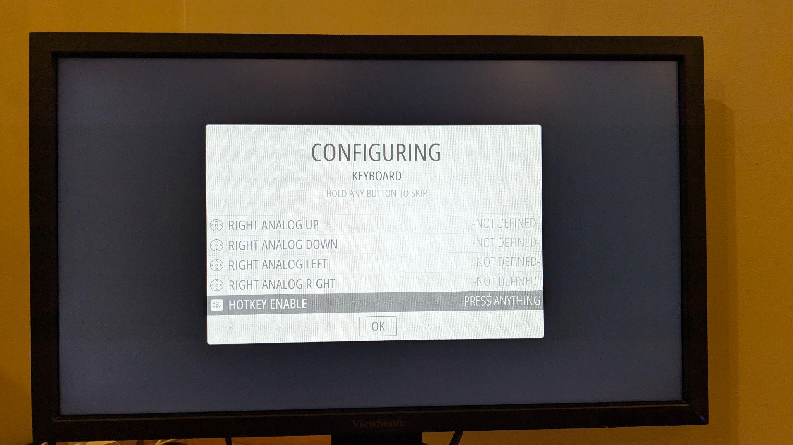
[Fig 11: EmulationStation Controller Configuration]

4.2 ROM Transfer and Organization

Network Transfer via SSH/SCP
- Identified Raspberry Pi IP address: 192.168.1.14
- Verified network connectivity using ping command
- Transferred ROM files using SCP protocol from Windows host
- Command: scp -r D:\Games\roms\* pi@192.168.1.14:~/RetroPie/roms/
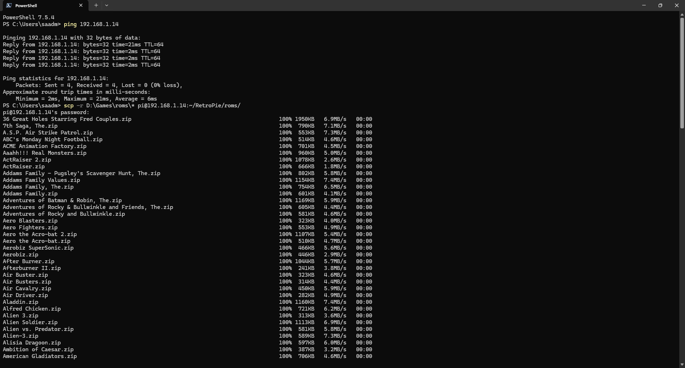
[Fig 12: PowerShell - Ping and SCP Transfer]

File System Organization
- SSH connection established to Raspberry Pi
- Created system-specific ROM directories (atari2600, arcade, etc.)
- Moved ROM files to appropriate directories using mv command
- Command: mv ~/RetroPie/roms/*.zip ~/RetroPie/roms/atari2600/
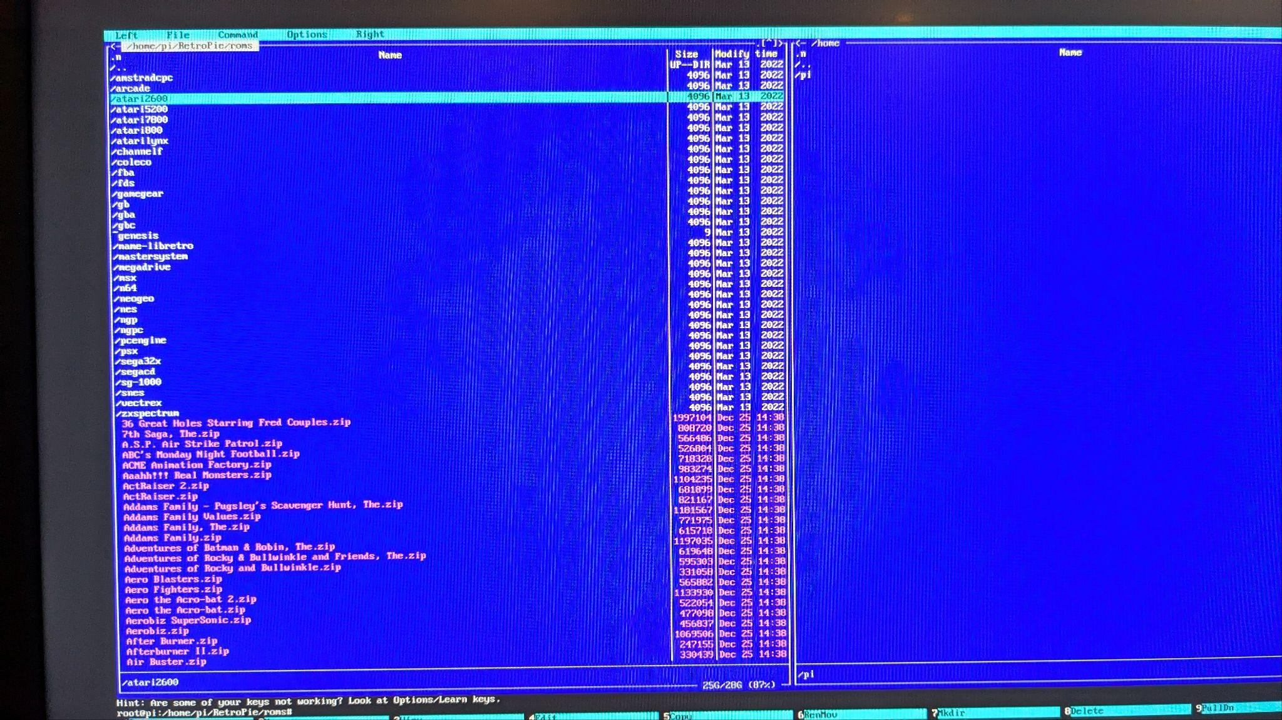
[Fig 13: SSH Terminal - File Organization]

4.3 System Configuration

Performance Optimization
- GPU Memory Split: Allocated 256MB to GPU (gpu_mem=256 in /boot/config.txt)
- CPU Governor: Set to 'performance' mode for consistent clock speeds
- Disabled unnecessary system services to reduce background processes

5. Implementation Challenges

5.1 Storage Media Limitations (microSD Card Issues)
One of the major challenges faced during the implementation was the use of a low-quality microSD card. The Raspberry Pi Imager repeatedly failed to flash the RetroPie operating system image onto the SD card, even after multiple attempts. This issue highlighted the sensitivity of the flashing process to storage media quality, particularly when writing large OS images.
To overcome this issue, alternative flashing software (BalenaEtcher) was used. Although BalenaEtcher also failed in initial attempts, repeated retries eventually resulted in a successful image write. However, the impact of the low-quality SD card persisted beyond installation.
During system usage and gameplay, frequent screen flickering, display signal loss, and intermittent blackouts were observed. These issues occurred due to slow read/write speeds and unstable data access from the microSD card, directly affecting I/O performance and system stability. This demonstrated how storage hardware plays a critical role in operating system reliability, boot consistency, and real-time application performance on embedded systems like Raspberry Pi.
Challenge | Solution | OS Concept
Under-voltage warnings during boot | Replaced with 5V/3A certified power supply | Hardware abstraction, power management
WiFi configuration failure | Used raspi-config to manually configure network settings | Network drivers, device configuration
Slow ROM loading times | Optimized file system performance, increased GPU memory allocation | File system I/O, memory management
Controller input lag | Configured RetroArch input latency settings, reduced audio buffer | I/O management, interrupt handling

6. Testing and Performance Metrics

6.1 System Performance
Metric | Measurement
Boot Time (Power-on to EmulationStation) | ~18 seconds
Average CPU Usage (Idle) | 15-20%
Average CPU Usage (Gaming) | 45-65%
RAM Usage (System + EmulationStation) | ~550MB / 3.7GB available
Operating Temperature (Under Load) | 40-48°C (CPU), 40-48°C (GPU)
Frame Rate (Atari 2600 Emulation) | Stable 60 FPS
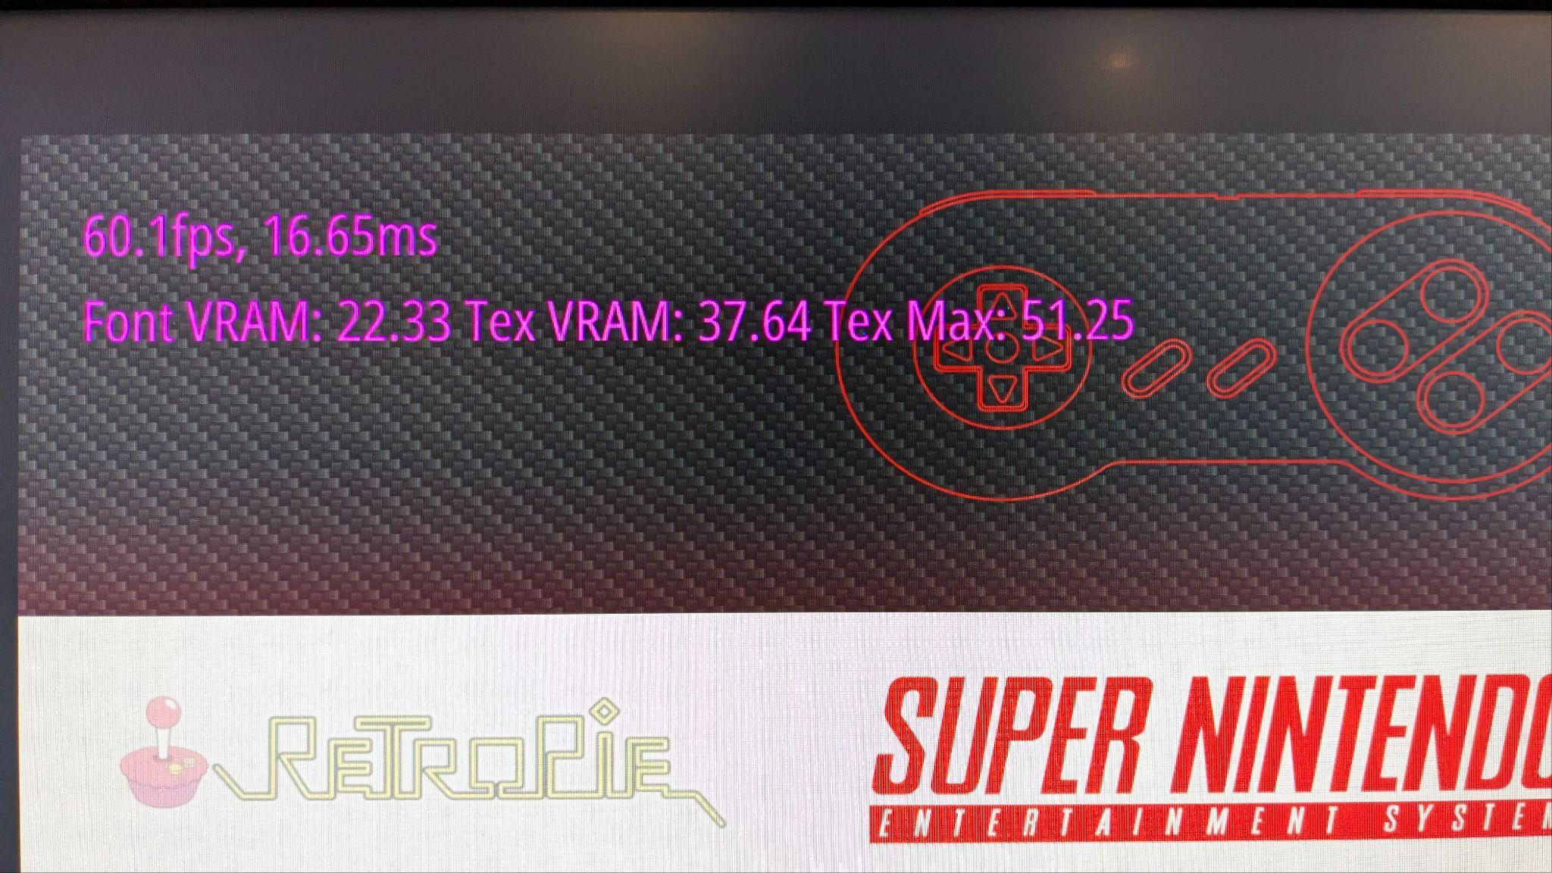
[Fig 14: System Monitoring (htop/Temperature)]

6.2 Functional Testing
- Controller input responsiveness: All buttons mapped and functioning correctly
- ROM loading: Games load within 2-3 seconds
- Save/Load states: Functionality verified across multiple games
- Network file transfer: SSH and Samba services operational
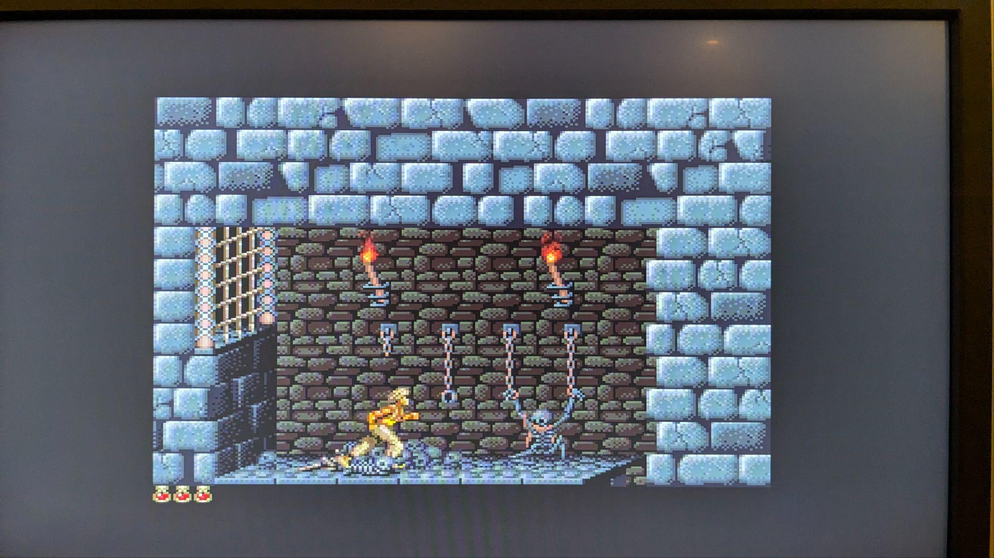
[Fig 15: Game Running (EmulationStation)]

7. Learning Outcomes

7.1 Technical Knowledge Gained
- Practical understanding of Linux boot process and systemd initialization
- Hands-on experience with process management and resource allocation
- Configuration of device drivers and hardware abstraction layers
- File system management and organization in Linux environment
- System service administration (SSH, Samba, network configuration)
- Performance optimization through OS-level configuration

7.2 Operating System Concepts Applied
- Layered OS architecture (hardware, kernel, services, applications)
- Process scheduling and multi-threading in real-time applications
- Memory management techniques (allocation, virtual memory, caching)
- I/O subsystem design for low-latency input processing
- Hardware-software interface through device drivers

8. Conclusion
The RetroPie gaming console project successfully demonstrates core operating system concepts through practical implementation. The project provided hands-on experience with Linux system administration, process management, memory optimization, file system organization, and hardware-software integration. Key achievements include successful OS installation and configuration, optimization of system performance for real-time gaming, implementation of network services, and comprehensive understanding of layered OS architecture. The project reinforced theoretical OS knowledge with practical skills in embedded Linux environments and system-level programming.

8.1 Future Enhancements
- Implementation of automatic ROM metadata scraping system
- Configuration of network-based multiplayer functionality
- Integration of additional emulator cores for expanded system support
- Implementation of automated backup system for save states and configurations

9. References
- RetroPie Official Documentation: https://retropie.org.uk/docs/
- Raspberry Pi Documentation: https://www.raspberrypi.org/documentation/
- Linux Kernel Documentation: https://www.kernel.org/doc/
- Operating Systems: Three Easy Pieces by Remzi H. Arpaci-Dusseau

10. Appendix
Command | Purpose
sudo raspi-config | System configuration utility
ping 192.168.1.14 | Network connectivity test
ssh pi@192.168.1.14 | Remote terminal access
scp -r files/ pi@IP:~/RetroPie/roms/ | Secure file transfer
mkdir -p ~/RetroPie/roms/system | Create ROM directories
sudo systemctl status nmbd | Check Samba service status
htop | Monitor system resources

